**Learning Aim B**

**Problem Definition**

Before I build the website, I have met up my clients to get information about the requirements of the website. I have gathered lots of information this will be beneficial as the more information I have from my clients the more likely I will be able to fulfil the requirements effectively.

I**ntended Audience**

The intended audience of the website is for my clients HotBeansWeb, they have told me that the target audience for their website is people who have completed training courses or qualifications related to web development and are now looking for a job as a web developer. When designing the website, I will keep in mind the target audience.

**Full summary of problem to be solved.**

I have met with the CEO of HotBeansWeb and they are looking for a website that contains a profile of the company, profiles of existing trainees web developers, job specifications and required qualifications, an on- line application form and links to web development courses. Other requirements are the website must be accessible to everybody.

**Constraints**

The constraints I have for making the website for HotBeansWeb is money as I do not have an unlimited budget, timescales I have limited time to create the website, staff training is another limitation as I must create the website by myself. Levels of security and support and maintenance contacts.

**Benefits**

There will be many benefits whenever I have developed the HotBeansWeb website. For example, the website will be available for anyone to access anytime of the day and from anywhere as the website is not restricted to one location. Overall, it will be cheaper for HotBeansWeb to have a website for advertising than paying for multiple advertisements like newspapers.

**Nature of interactivity**

During the meeting with my client, we discussed interactivity regarding the website. My client has requested a movie, scrolling text, am image gallery, a map and dropping text. The client however also has requested an equal balance of static and dynamic content as does not want the website to be overwhelming for the users.

**Wireframe Template**

|  |  |  |  |  |
| --- | --- | --- | --- | --- |
| Image- HotBeansWebBanner  Size- width 100% height 350 | | | | |
| Text- Home  Font- Franklin Gothic Medium  Size- Large  Colour- Black | Text- The Team  Font- Franklin Gothic Medium  Size- Large  Colour- Black | Text- Requirements  Font- Franklin Gothic Medium  Size- Large  Colour- Black | Text- Apply  Font- Franklin Gothic Medium  Size- Large  Colour- Black | Text- Courses  Font- Franklin Gothic Medium  Size- Large  Colour- Black |
| Editable Region | | | | |
| Text- Contact information  Font- Franklin Gothic Medium  Size- Large  Colour- Black | | Text- Follow our social media.  Font- Franklin Gothic Medium  Size- Large  Colour- Black | Image- Twitter logo  Size- width 50 height 50 | Image- Tiktok logo  Size- width 50 height 50 |

On the template I will be adding a banner that I have created on photoshop to the top of the website and underneath I will add a horizontal navigation bar. In the editable region I will add text and images. The footer will contain contact information and links to the social media pages.

**Alternative design:** Another way I could have designed the template is to have the navigation bar vertical instead of horizontal. I could have also added images going down the page and swapped the position of the text and images in the footer.

**Client’s vision:** After meeting with my client HotBeansWeb they are hoping for the website layout of the template to have banner at the top of the page which will be red. The client also has requested a horizontal navigation bar with 5 different pages; home, meet the team, requirements, apply and courses. HotbeansWeb is wishing to include a footer which will contain 4 columns and links to their social media, email address and phone number.

**Index**

|  |  |  |
| --- | --- | --- |
| Template | | |
| Scrolling Marquee- Welcome to hotbeansweb!  Size large  Font-Franklin Gothic Medium  Colour- Black | | |
| Text- About us and information  Size- Medium  Font- Franklin Gothic Medium  Colour- Black | Image- Hot Beans Ceo  Size- Width 150 height 150 | Text- Ceo of HotBeansWeb Leo Brady  Font- Franklin Gothic Medium  Size- Large  Colour- Black |
| Text- Tour of the Office  Size- Medium  Font- Franklin Gothic Medium  Colour- Black |  |  |
| Movie- Tour of office web video  Size- height 140 width 100%  I am planning to make a movie on iMovie and this movie will contain images and text regarding the office building. | | |
| Template | | |

Below the navigation bar I will be adding a scrolling marquee text welcoming users to the website. There will then be text below that giving users some general about the business information then I am planning to create a movie on iMovie and add it to the page the movie will contain images of the office and headings. I am going to add an image of the CEO of hotbeansweb.

**Alternative Design:** I could have put the movie at the top of the page and the about us information then below that. I could have put the image of the CEO at the left-hand side of the page instead of the right-hand side.

**Client’s vision:** After meeting with the client, they have requested that the index page should contain 4 rows and 3 columns. They have also requested for me to create a movie for the website which will contain images of their office. My client is hoping for there to be an image of the CEO and general information about the business.

**Meet The Team**

|  |  |  |
| --- | --- | --- |
| Template |  |  |
| Image-Ceo Leo Brady  Size- width 300 height 300 | Text- Ceo Leo Brady  Size- Medium  Font- Franklin Gothic Medium  Colour- Black | Photo Gallery with images of staff |
| Image- employee 1  Size- width 300 height 300 | Text- Development Director Noah Murphy  Size- Medium  Font- Franklin Gothic Medium  Colour- Black |  |
| Image- employee 2  Size- width 300 height 300 | Text- Senior Web developer Charlotte Murray  Size- Medium  Font- Franklin Gothic Medium  Colour- Black |  |
| Image- employee 3  Size- width 300 height 300 | Text- Junior Web developer Amelia Lynch  Size- Medium  Font- Franklin Gothic Medium  Colour- Black |  |
| Template | | |

On this page I’m planning to add images of the staff who work at hotbeans web and horizontal to that a short bit of text outlining their role in the business. I am also going to a add a photo gallery which will contain images of the staff.

**Alternative Design:** Another way I could have designed this page is have the text on the left-hand side of the page and then images on the right. Or have the images of staff horizontal on the page and then the text below.

**Client’s vision:** After meeting with the client, they have requested that the Meet the Team page contains 3 columns and 4 rows. They have requested that the first column has images of each of the staff in separate rows and in the second column have text of their roles all in a separate roll. My client is hoping for me to include a photo gallery using script and for the photo gallery to contain images of all the staff in the business.

**Requirements**

|  |  |  |  |
| --- | --- | --- | --- |
| Template | | | |
| Text- Join Our Team!  Flying letters script  Size- Large  Font- Franklin Gothic Medium  Colour- Black | | | |
| Image- Requirements  Size- width 1176 height 278 | | | |
| Text- Information about the jobs  Size- Medium  Font- Franklin Gothic Medium  Colour- Black | | | |
| Text- Information about requirements  Size- Medium  Font- Franklin Gothic Medium  Colour- Black | Text- Full time junior web developer  Size- Medium  Font- Franklin Gothic Medium  Colour- Black | Text- Part time junior web developer  Size- Medium  Font- Franklin Gothic Medium  Colour- Black | Text- Information about requirements  Size- Medium  Font- Franklin Gothic Medium  Colour- Black |
| Template | | | |

I am planning to add falling text to add a dynamic element to this page. Below this I will have an image and then the job rolls and text describing the roles.

**Alternative Design**: An alternative way to design this page is have the image at the bottom of the website and have all the information at the top of the website.

**Client’s vision:** I have met with the client from hotbeansweb and they have requested that on the requirements page to include 4 rows and 4 columns. The first column will contain flying text using script and then below that an image. The client has requested that at the bottom of the page I include text for the two jobs and some brief information about them.

**Apply**

|  |  |  |  |  |
| --- | --- | --- | --- | --- |
| Template | | | | |
| Text- Brief overview of applying  Size- Large  Font- Franklin Gothic Medium  Colour- Black | Text- Title  Size- Large  Font- Franklin Gothic Medium  Colour- Black | Drop down box  Text- Mr/Mrs  Size-140 width 100 height |  |  |
|  | Text- Name  Size- Large  Font- Franklin  Gothic Medium  Colour- Black | Text Box  Size 140 width 50 height |  |  |
| Google maps embedded of Belfast  Size-200 width 200 height | Text- Email  Size- Large  Font- Franklin Gothic Medium  Colour- Black | Text Box  Size 140 width 50 height | Gif- Email logo  Size- Width 150 height 150 |  |
|  | Text- Phone Number  Size- Large  Font- Franklin Gothic Medium  Colour- Black | Text Box  Size 140 width 50 height | Gif- Phone icon  Size- Width 150 height 150 |  |
|  |  | Submit button  Size- 140 width 100 height | Reset Button  Size- Width 140 100 height |  |
| Template | | | | |

On the apply page I am planning to add an application form this will contain a drop-down box for their title multiple text boxes and a submit and reset button on vertical to each other. I also wish to add Gif images and to embed a google map with the location of the headquarters.

**Alternative Design**: I could have added the google map at the right-hand side of the page and then the text boxes in a different order.

**Client’s vision:** After meeting with the client,they have requested that on the apply page I include 5 columns and 5 rows. They have requested that a google map to be embedded and show users the location of the office, they also request gif images and submit and reset buttons for users to be able to send their application to HotBeansWeb.

**Courses**

|  |  |  |
| --- | --- | --- |
| Template | | |
| Text- Brief overview of courses  Size- Large  Font- Franklin Gothic Medium | | |
| Text- Beginner course and information  Size- Medium  Font- Franklin Gothic Medium  Colour- Black | Text- Intermediate course and interview  Size- Medium  Font- Franklin Gothic Medium  Colour- Black | Text- Advanced Course and information  Size- Medium  Font- Franklin Gothic Medium  Colour- Black |
| Image- course 1  Size- width 300 height 300 | Image- course 2  Size- width 300 height 300 | Image- course 3  Size- width 300 height 300 |
| Template | | |

I am planning to have text with an overview of the different courses then have images of the courses and have text that is hyperlinked to the website of the course. I will have this in 3 columns and 3 rows.

**Alternative Design:** Another way I could have designed the courses page is have the courses in a different order starting with advanced then to beginner. I also could have had all the text vertical and then images horizontal to the text.

**Client’s vision:** I have met with my client hotbeansweb and they have requested that the courses page should include 3 rows and 3 columns. IN the first column that wish to have a brief overview of the courses. They wish for the second row to have the different courses and with information in each of the columns. For the third row HotBeansWeb has requested for them to be different images included.

**Realistic Representation**

I have met with my client we have discussed the storyboards and wireframe. My client was happy with the colours, font and sizing. My client has chosen for the colour theme to be red and include white space they have also chosen for the font to be franklin gothic medium. They wish to include images and hyperlinks on all pages so that the website is interactive.

**Navigational Structure Frame**

Apply

Requirements

Courses

The Team

Index

**Obtaining and using feedback from others**

<https://forms.gle/VJVRYDcZvjMeJGZLA>

I have created a google form. On this google form I have included ratings of all pages and what users dislike or like about the website. I have also added an option for users to give me feedback. Once I have received the feedback, I will then make improvements to the website user the users feedback.

I have met with the client after creating the website. The feedback I received was that they were satisfied with the colour scheme, font, movie and other interactive features. However, the client did not like the lack of text and since then I have added more text. My client also recommended for me to add more interactive features to the website, I have since then added a scrolling marquee text.

I met with my client for the last time, and they were completely satisfied with the website, and I have received no recommendations for improvements.

**Story Board**

Index

Internal link

External sites

www.[codeacademylearnhtml.com](https://www.codecademy.com/learn/learn-html)

www.[johnaccademywebdevelopment.com](https://www.johnacademy.co.uk/course/web-development-intermediate-level/)

www.j[anetsintermediatecourse.com](https://www.janets.org.uk/courses/web-development-intermediate-level/)

www.[wordpresswebdesignprofesional.com](https://www.reed.co.uk/courses/wordpress-web-design--professional-web-design-course/283249?utm_medium=course_share&utm_campaign=course_details&utm_content=course_283249&utm_source=other)

I will create a horizontal navigation bar on the website. This navigation bar will be added to the template so every page can be accessed from any page on the website, this will make the website easier to use for users. On the footer of the page there is images of a TikTok logo and a Twitter these images are linked to the TikTok website and the twitter website. These links can be accessed on the bottom of every page. On the courses page there is there is 4 websites all hyperlinked to the websites. These links can only be accessed on the courses page.

External site www.tiktok.com

External site www.tiktok.com

External site www.tiktok.com

External site www.tiktok.com

External site www.twitter.com

External site www.twitter.com

External site www.twitter.com

External site www.twitter.com

Apply

Courses

The Team

Requirements

**Testing**

I am testing the website to check that all parts of the website work as they should.

I have tested the website in google chrome and Microsoft edge.

|  |  |  |  |  |  |
| --- | --- | --- | --- | --- | --- |
| Test Number | Purpose of test | On page | Test data | Expected Result | Actual result/Screenshot |
| 1 | Test the scrolling text | Index.html | Load page | For the text to scroll left to right | The text scrolled from left to right. |
| 2 | Accessibility text resizer | Index.html | Click “+larger font/=smaller font” | Text should get larger or smaller depending on which was clicked |  |
| 3 | Test the movie loads | Index.html | Load page | For movie to play | Movie does not play when opened in internet explorer browser. |
| 4 | Testing if image loads | Index.html | Load page | Image should load | Image loaded on the index page |
| 5 | Test hyper link of twitter logo | All pages | Click on the twitter image | For the twitter website to load | Link opened to twitter page |
| 6 | All images chosen will show in the photo gallery | Theteam.html | Click the next button | Image will change when next is clicked | All images loaded and changed when I clicked next |
| 7 | Images should load on page | Theteam.html | Load page | Images should all load and if not show alt text | The images loaded on the team page. |
| 8 | The next and back button work in the photo gallery | Theteam.html | Click next/back buttons | Images should change when buttons are pressed | The images changed when the next and back button were pressed |
| 9 | Start over button works | Theteam.html | Click the start over button | Gallery should show the first picture | The first image in thr gallery loaded when I clicked ther start over button |
| 10 | Falling text appears | Requirements.html | Load page | Characters individually fall then will form sentence Join our team! | Characters individually fell then formed sentence Join our team |
| 11 | Hyperlink loads correct page | Requirements.html | Click “here” | When “here” is clicked it should open the apply.html page |  |
| 12 | Image loads | Requirements.html | Load page | The image should load on page | The image loaded when I loaded the page |
| 13 | Drop Box menu works | Apply.html | Click the arrow | Option to choose Mr or Mrs appears | The Mr and Mrs option appeared |
| 14 | Google Map loads | Apply.html | Load page | Google map to appear on Belfast |  |
| 15 | Submit button works | Apply.html | Click submit button | Submits and clears text |  |
| 16 | Reset Button works | Apply.html | Click reset button | Text resets | Text didn’t reset |
| 17 | Banner Loads | All pages | Load page | The banner I created loads | Banner loaded |
| 18 | Hyperlinks for webpages open | Courses.html | Click links | New webpage opens |  |
| 19 | Phone gif moves | Apply.html | Load page | Gif should animate |  |
| 20 | Navigation bar opens new page | All pages | Click on “The Team” | The team page should open |  |
| 21 | Navigation bar works and opens requirements page | All pages | Click on “requirements” | The requirements page should open |  |
| 22 | Navigation bar works and opens apply page | All pages | Click on “apply” | The apply page should open |  |
| 23 | Navigation bar works and opens courses page | All pages | Click on “courses” | The courses page should open |  |
| 25 | Browser testing | All pages | Load website | The website should load is google chrome and in Microsoft edge. | The website loaded on google chrome and on microsoft edge. |

**Gant chart**

This Gant chart is a quick overview of the tasks I have completed in order to create and hand in the website and on what week I did each individual task.

|  |  |  |  |  |  |  |  |  |  |  |
| --- | --- | --- | --- | --- | --- | --- | --- | --- | --- | --- |
| Tasks/Weeks | 1 | 2 | 3 | 4 | 5 | 6 | 7 | 8 | 9 | 10 |
| Read Task |  |  |  |  |  |  |  |  |  |  |
| Learn Photoshop |  |  |  |  |  |  |  |  |  |  |
| Create Banner |  |  |  |  |  |  |  |  |  |  |
|  |  |  |  |  |  |  |  |  |  |  |
| Learn Web Expression |  |  |  |  |  |  |  |  |  |  |
| Design Website |  |  |  |  |  |  |  |  |  |  |
|  |  |  |  |  |  |  |  |  |  |  |
| Create Template |  |  |  |  |  |  |  |  |  |  |
| Create Index. HTML |  |  |  |  |  |  |  |  |  |  |
| Create MeetTheTeam.html |  |  |  |  |  |  |  |  |  |  |
| Create Requirements.html |  |  |  |  |  |  |  |  |  |  |
| Create apply.html |  |  |  |  |  |  |  |  |  |  |
| Create Courses.html |  |  |  |  |  |  |  |  |  |  |
|  |  |  |  |  |  |  |  |  |  |  |
| Test |  |  |  |  |  |  |  |  |  |  |
| Optimisation |  |  |  |  |  |  |  |  |  |  |
| Evaluate |  |  |  |  |  |  |  |  |  |  |
| Present Website |  |  |  |  |  |  |  |  |  |  |
| Make Improvements |  |  |  |  |  |  |  |  |  |  |
| Hand In website |  |  |  |  |  |  |  |  |  |  |

**Corrective measures**

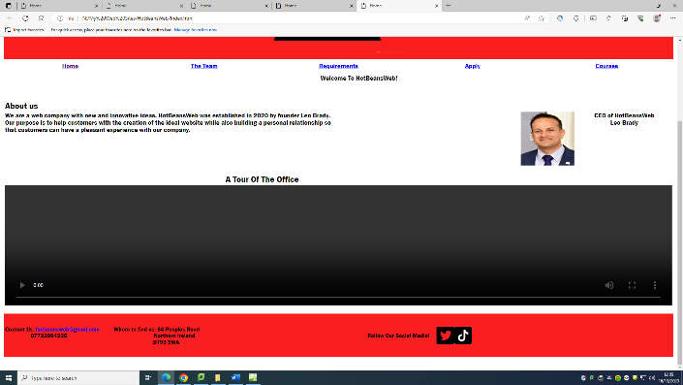

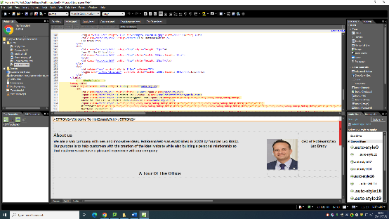

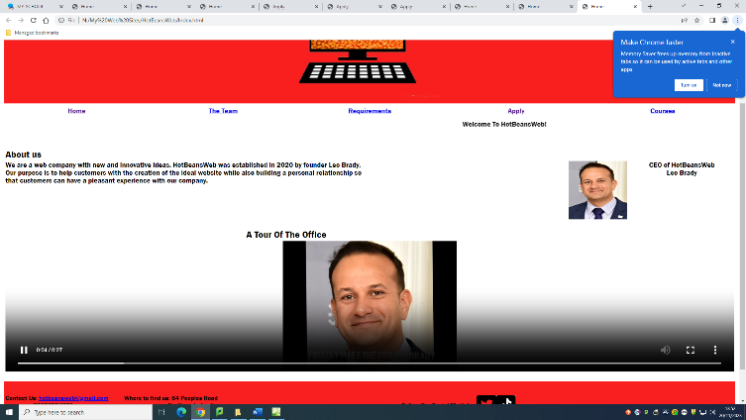

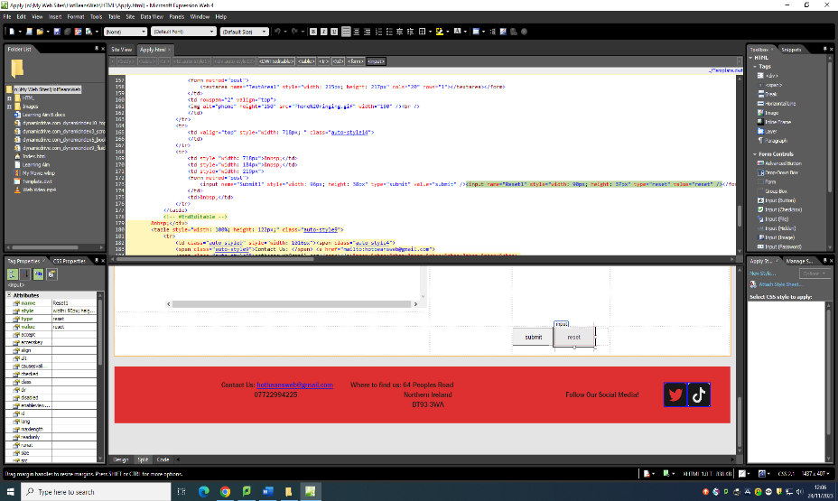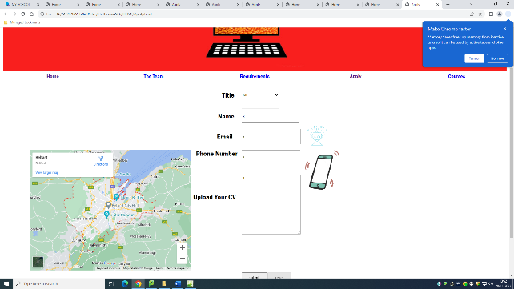

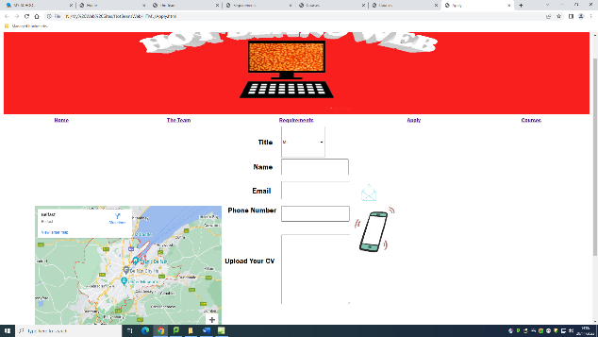

Code from code table which allowed me to add the change of font.

Code from code table which allowed me to add the movie.

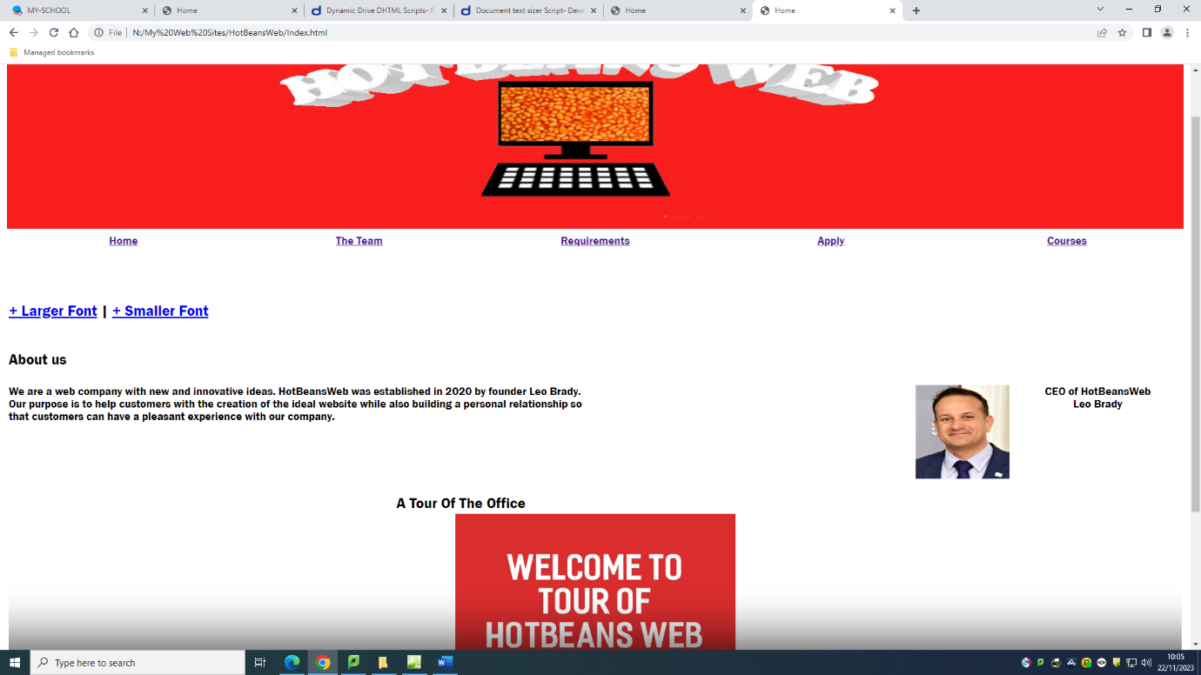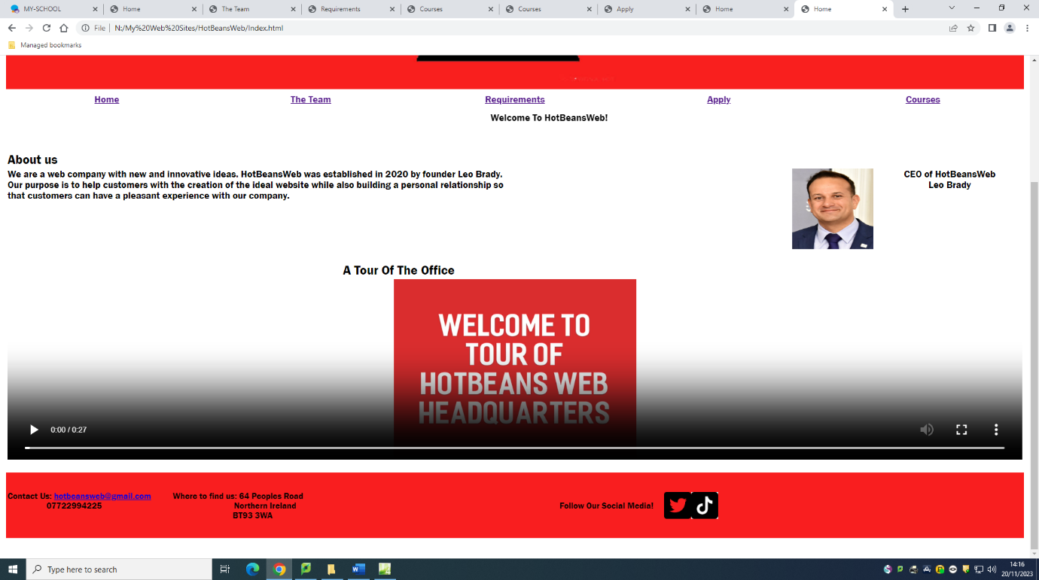

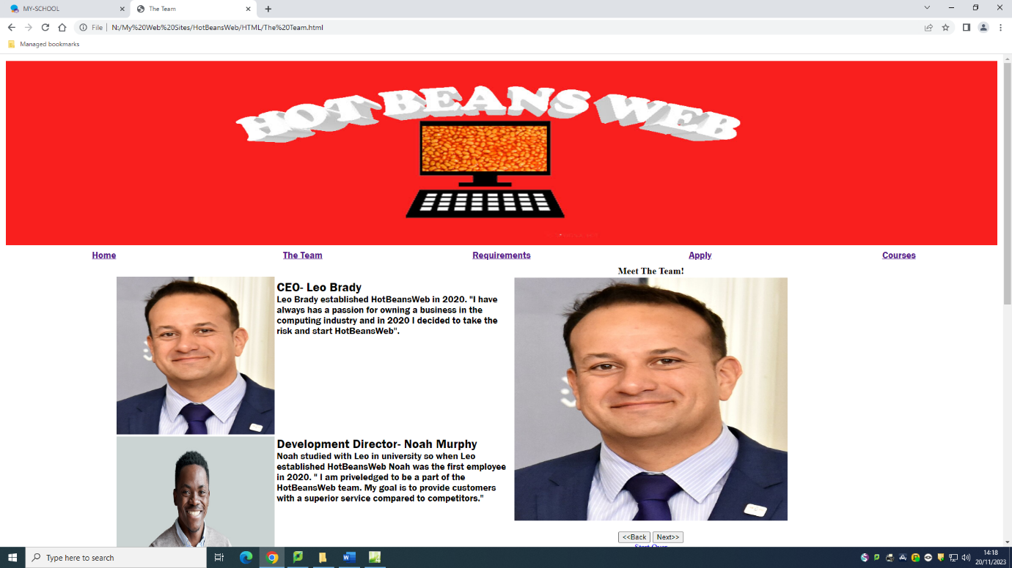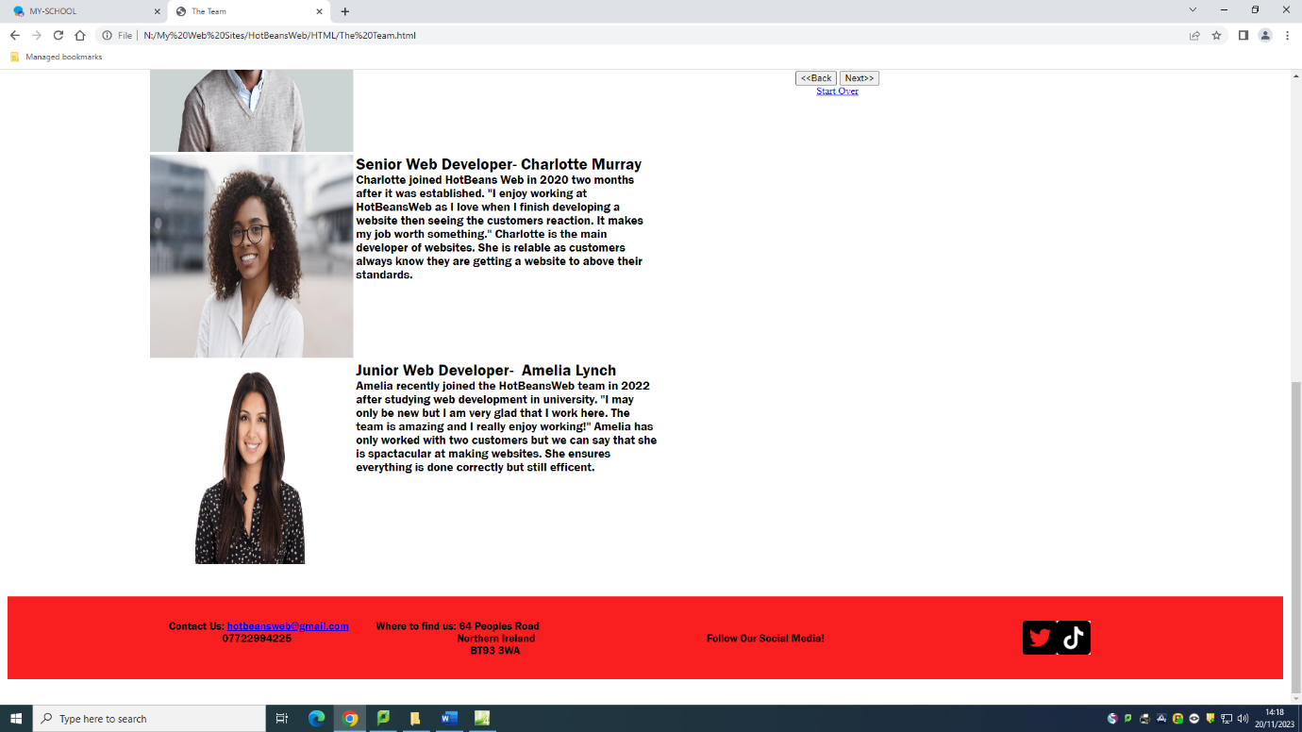

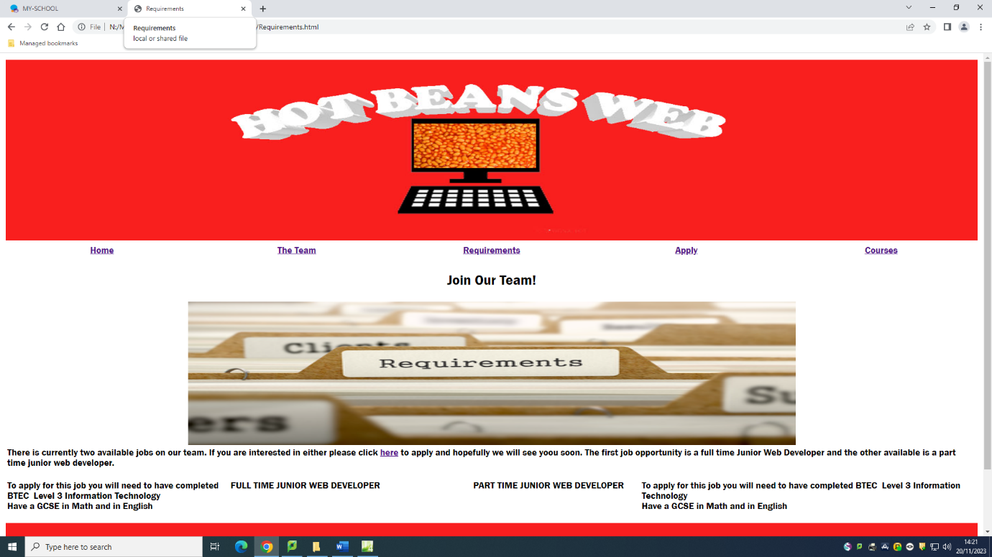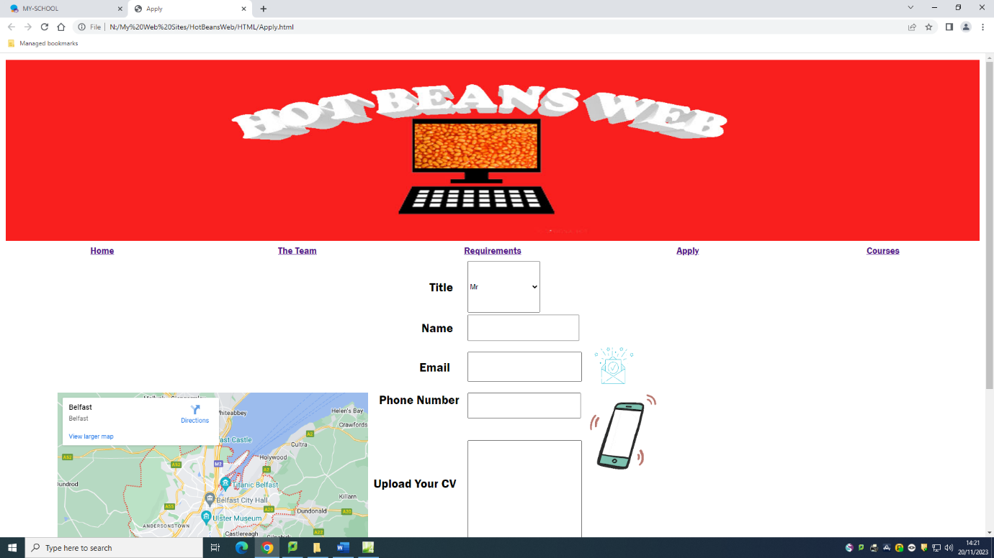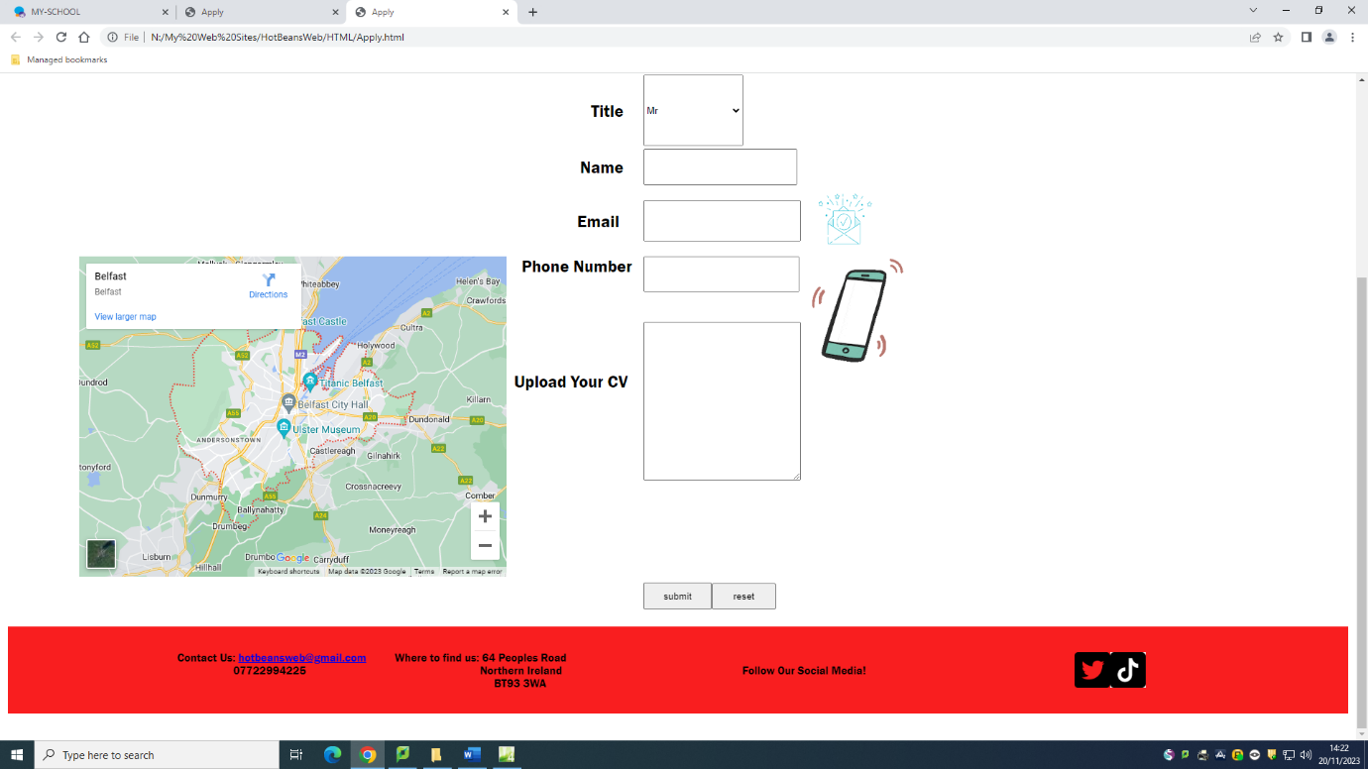

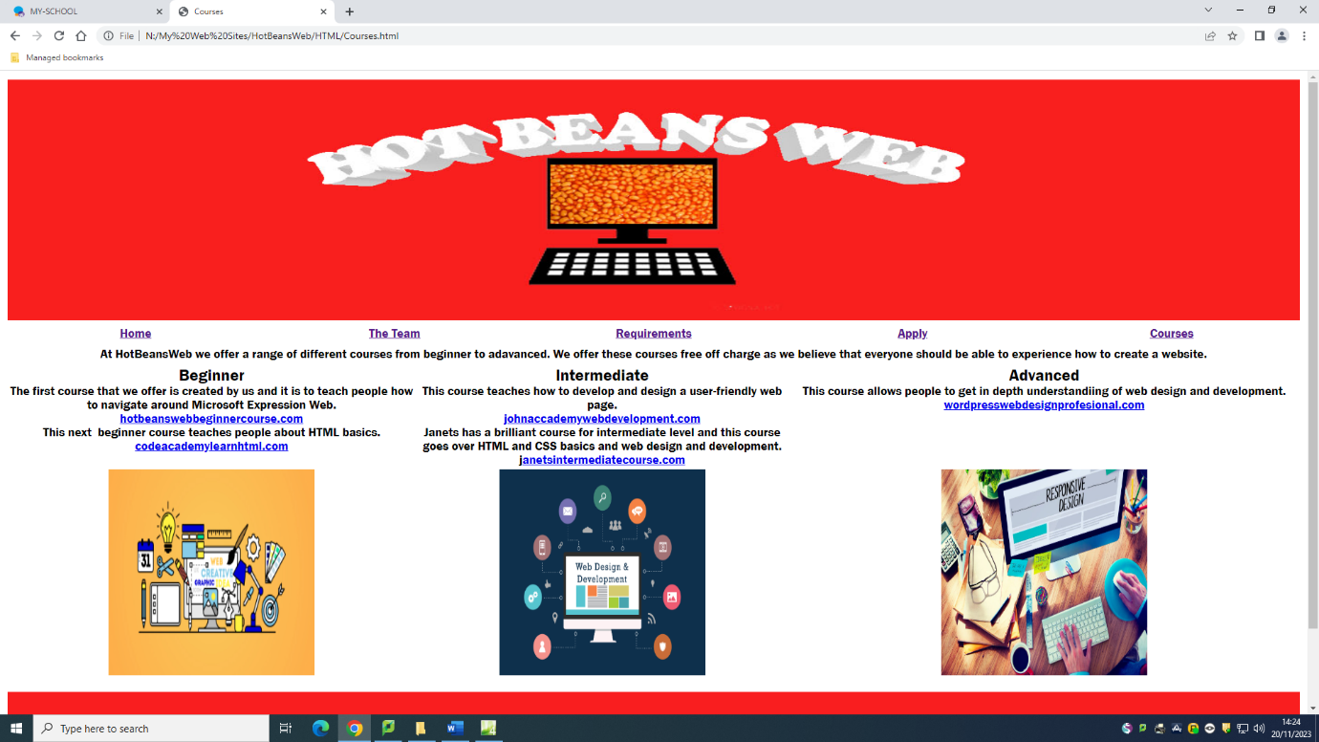

**Bibliography**

1~<https://uk.pcmag.com/web-hosting/8476/how-to-create-a-website>

Accessed-6/09/23

2~<https://www.wix.com/blog/5-design-tips-for-a-professional-site>

Accessed-6/09/23

3~<https://zapier.com/blog/best-website-builders/>

Accessed-8/09/23

4~<https://www.edrawmax.com/banner/how-to-make-a-banner-in-photoshop/>

Accessed-15/09/23

5~<https://www.speedpro.com/blog/design-tips-to-create-the-perfect-banner/>

Accessed-15/09/23

6~ <https://www.adobe.com/uk/products/photoshop.html>

Accessed-15/09/23

7~ <https://www.hostinger.co.uk/tutorials/web-accessibility?ppc_campaign=google_search_generic_hosting_all&bidkw=defaultkeyword&lo=1007274&gad_source=1&gclid=EAIaIQobChMIzsaigrbkggMVIpZQBh1-wwWOEAAYBCAAEgINEPD_BwE>

Accessed-19/9/23

8~ <https://uk.pcmag.com/video-editing/145145/make-a-movie-how-to-create-and-edit-videos-in-imovie-on-your-phone>

Accessed- 20/9/23

9~ <http://www.dynamicdrive.com/>

Accessed- 21/9/23

10~ <https://www.google.com/maps/@54.667775,-6.8021395,8z?entry=ttu>

Accessed- 29/9/23

|  |  |
| --- | --- |
| This is the code adds accessibility to the website. It is contained on the top of every page and can either largen text or make text smaller. | <td class="auto-style19" valign="top"><a href="javascript:ts('body',1)">+ Larger Font</a> | <a  href="javascript:ts('body',-1)">+ Smaller Font</a><div id="sizecontroldiv" class="controlstyle"> |
| This is the code for the video I made. The code is contained on the index page | <video src="Web Video.mp4" controls style="width: 100%; height: 336px"></video></td></tr> |
| This code is on the index page. It makes the text scroll from left to right. | <MARQUEE bgcolor="#FFFFFF" direction="right" loop="1000" width="100%" class="auto-style17"><STRONG>Welcome To HotBeansWeb!</STRONG></MARQUEE></FONT></DIV></td></tr> |
| Using this code allowed me to add a photo gallery into the team page of the website. | <img src="../Images/leo CEO.jpg" width="518" height="462" name="photoslider" style="float: right"></td>  </tr>  <tr>  <td width="100%"><form method="POST" name="rotater">  <div align="center"><center><p><script language="JavaScript1.1">  var photos=new Array()  var which=0  /*Change the below variables to reference your own images. You may have as many images in the slider as you wish*/  photos[0]="../Images/leo CEO.jpg"  photos[1]="../Images/employee 1.jpg"  photos[2]="../Images/employee 2.jpg "  photos[3]="../Images/employee 4.jpg"  function backward(){  if (which>0){  window.status=''  which--  document.images.photoslider.src=photos[which]  }  }  function forward(){  if (which<photos.length-1){  which++  document.images.photoslider.src=photos[which]  }  else window.status='End of gallery' |
| This code shows text flying down into order. It is on the requirements page | <td colspan="4"><h2 id="fly" class="auto-style14">Join Our Team!</h2>  <script type="text/javascript">  //Flying Letters script- by Matthias (info@freejavascripts.f2s.com)  // Modified by Twey for efficiency and compatibility  //For this script and more, visit Dynamic Drive: http://www.dynamicdrive.com  //Configure message to display. Use "$" for linebreak  //By default, set to just grab the text from element with ID="fly"  message = document.getElementById("fly").innerHTML; // $ = taking a new line  distance = 50; // pixel(s)  speed = 200; // milliseconds  var txt="",  num=0,  num4=0,  flyoff="",  flyofwi="",  flyofto="",  fly=document.getElementById("fly");  function stfly() {  for(i=0;i != message.length;i++) {  if(message.charAt(i) != "$")  txt += "<span style='position:relative;visibility:hidden;' id='n"+i+"'>"+message.charAt(i)+"<\/span>";  else  txt += "<br>";  }  fly.innerHTML = txt;  txt = "";  flyofle = fly.offsetLeft;  flyofwi = fly.offsetWidth;  flyofto = fly.offsetTop;  fly2b();  }  function fly2b() {  if(num4 != message.length) {  if(message.charAt(num4) != "$") {  var then = document.getElementById("n" + num4);  then.style.left = flyofle - then.offsetLeft + flyofwi / 2 + 'px';  then.style.top = flyofto - then.offsetTop + distance + 'px';  fly3(then.id, parseInt(then.style.left), parseInt(then.style.left) / 5, parseInt(then.style.top), parseInt(then.style.top) / 5);  }  num4++;  setTimeout("fly2b()", speed);  }  }  function fly3(target,lef2,num2,top2,num3) {  if((Math.floor(top2) != 0 && Math.floor(top2) != -1) || (Math.floor(lef2) != 0 && Math.floor(lef2) != -1)) {  if(lef2 >= 0)  lef2 -= num2;  else  lef2 += num2 * -1;  if(Math.floor(lef2) != -1) {  document.getElementById(target).style.visibility = "visible";  document.getElementById(target).style.left = Math.floor(lef2) + 'px';  } else {  document.getElementById(target).style.visibility = "visible";  document.getElementById(target).style.left = Math.floor(lef2 + 1) + 'px';  }  if(lef2 >= 0)  top2 -= num3  else  top2 += num3 * -1;  if(Math.floor(top2) != -1)  document.getElementById(target).style.top = Math.floor(top2) + 'px';  else  document.getElementById(target).style.top = Math.floor(top2 + 1) + 'px';  setTimeout("fly3('"+target+"',"+lef2+","+num2+","+top2+","+num3+")",50)  }  }  stfly() |
| This is the code which when added presents a google map image of the chosen location. This code is on the apply page | function onApiLoad() {  var embed = document.createElement('script');  embed.src = "https://maps.gstatic.com/maps-api-v3/embed/js/55/2/init_embed.js";  document.body.appendChild(embed);  }  </script>  <script src="https://maps.googleapis.com/maps/api/js?client=google-maps-embed&amp;paint_origin=&amp;libraries=geometry,search&amp;v=3.exp&amp;language=en&amp;region=uk&amp;callback=onApiLoad" nonce="KHzd1-8cfeiT-sRtDMnTFQ" async defer></script>  </body>  </html> |

**My Code**

I used code from dynamic drive to add accessibility to all pages. This code increases or decreases size of text. I did not change any of the code when inserting it.

I used a code from schools shared recourses when adding movie to my webpage. I change the width and height in the code.

I used a code from shared resources to add a scrolling marquee on the index page. I changed the text, background colour and size of the code.

I have used a code from shared recourses in the Meet the Team page. This code is for a photo gallery. I have changed the size and images in the code.

I used a code from dynamic drive which presents as characters falling into a sentence. I changed the text of the code.

I used a code from google which allowed me to enter a google map into the apply page. I did not change anything about the code.

**Cascading Style Sheets**

Cascading style sheets are used to ensure standardised formatting across a website, it is beneficial for me to use CSS while making the HotBeansWeb website as it allows me to use the same layout and styling throughout a website. CSS allows web developers to create a standard layout and style which can then easily be applied to all web pages across a website. They are cascading in that when you make a change in one place within a website this change will be cascaded to all the web pages within the website that use that style. This therefor makes altering and maintaining the design of a website easier. For example, if I was using HTML to change the font colour of all the titles to yellow on the website, I would individually have to change each one but since I am using HTML5 and CSS only one value would need to be changed and then that change will immediately be applied throughout the HotBeansWeb website for every title. CSS help with optimisation

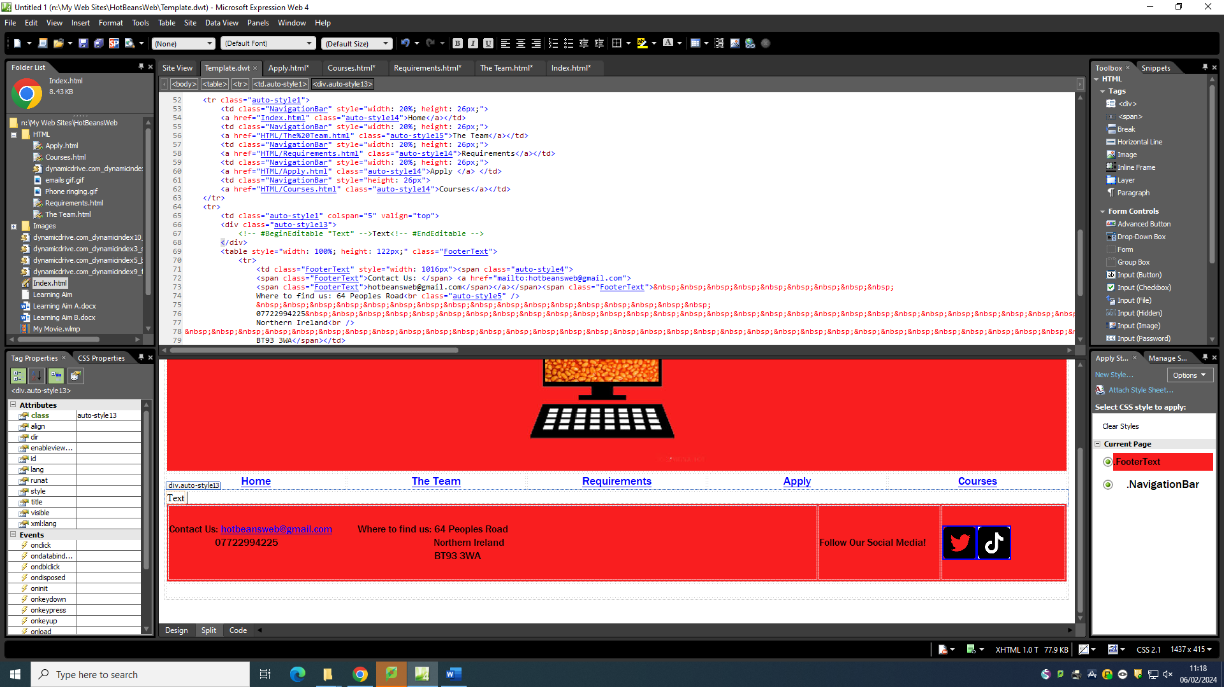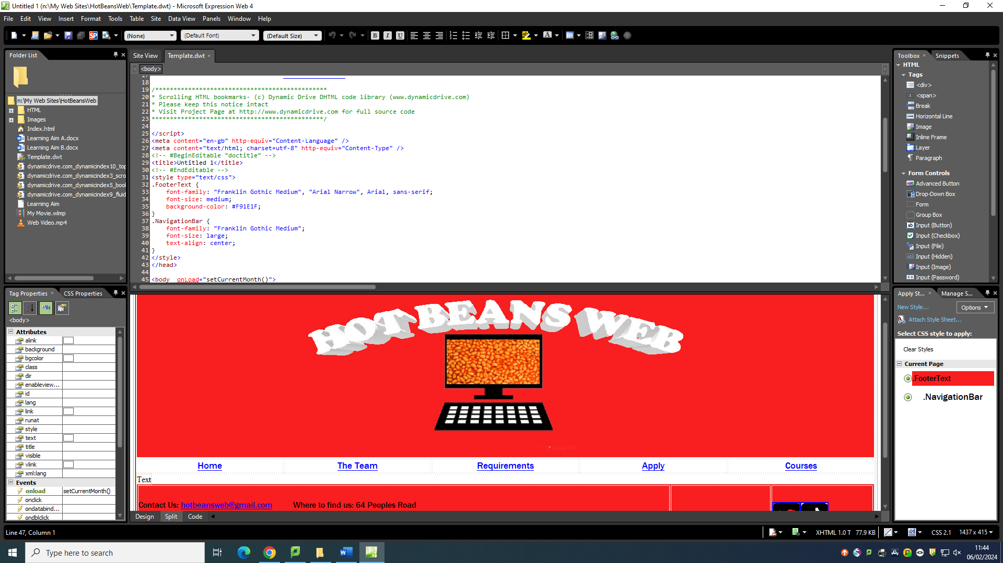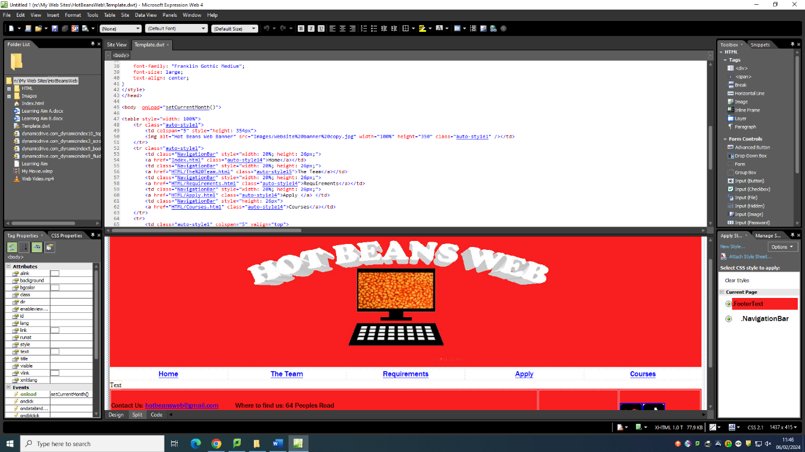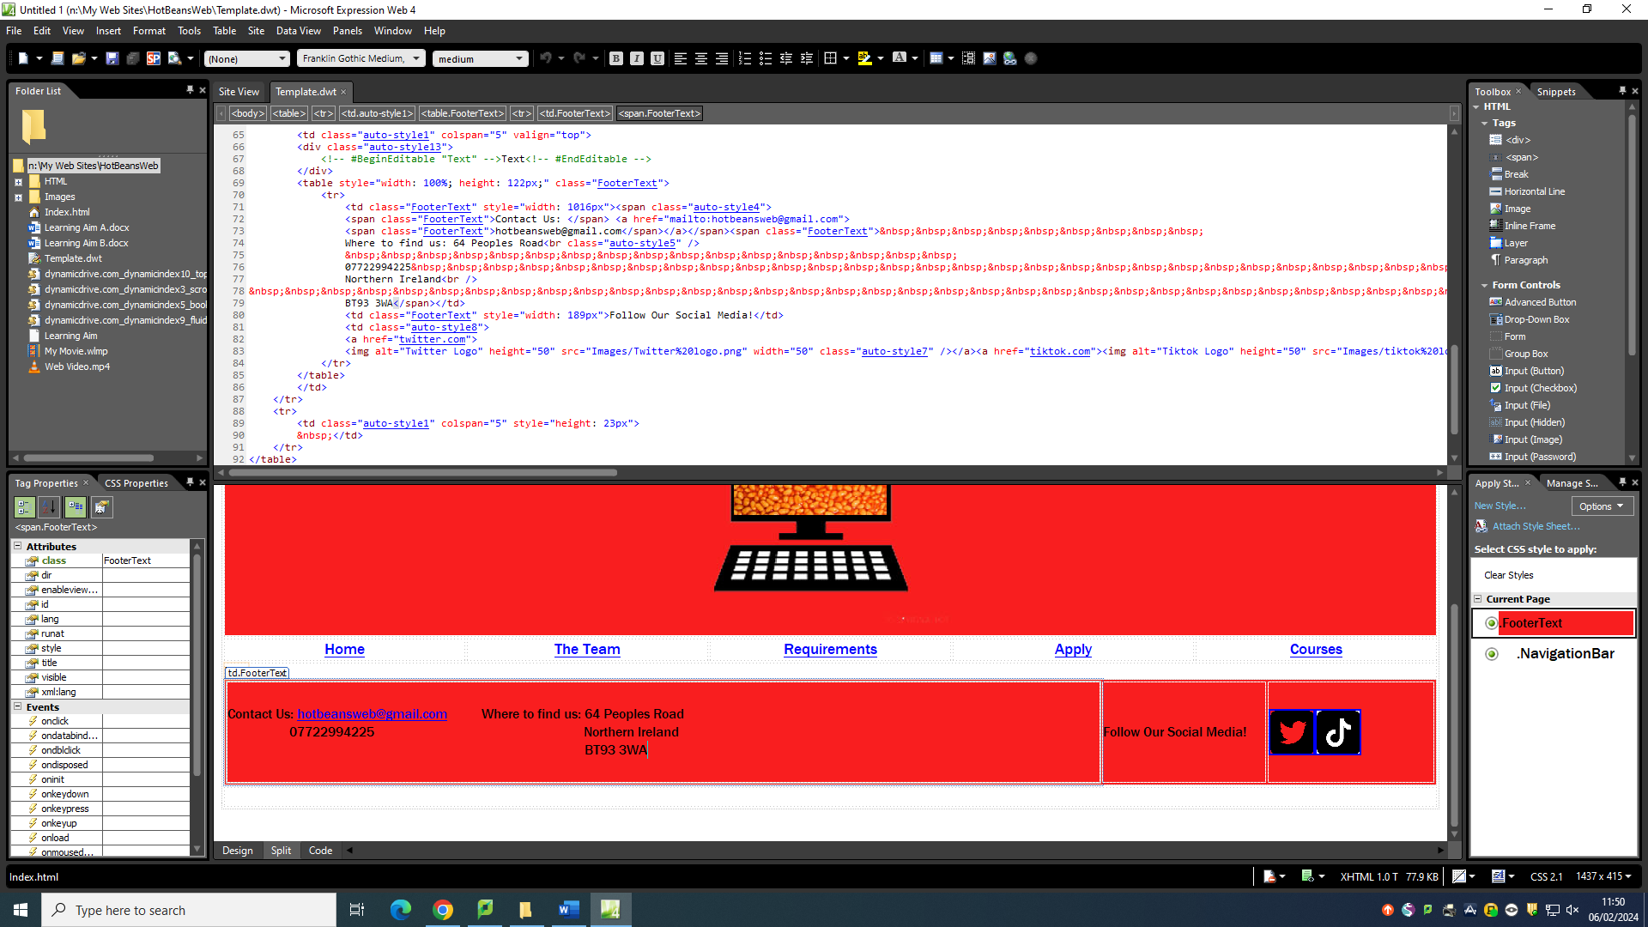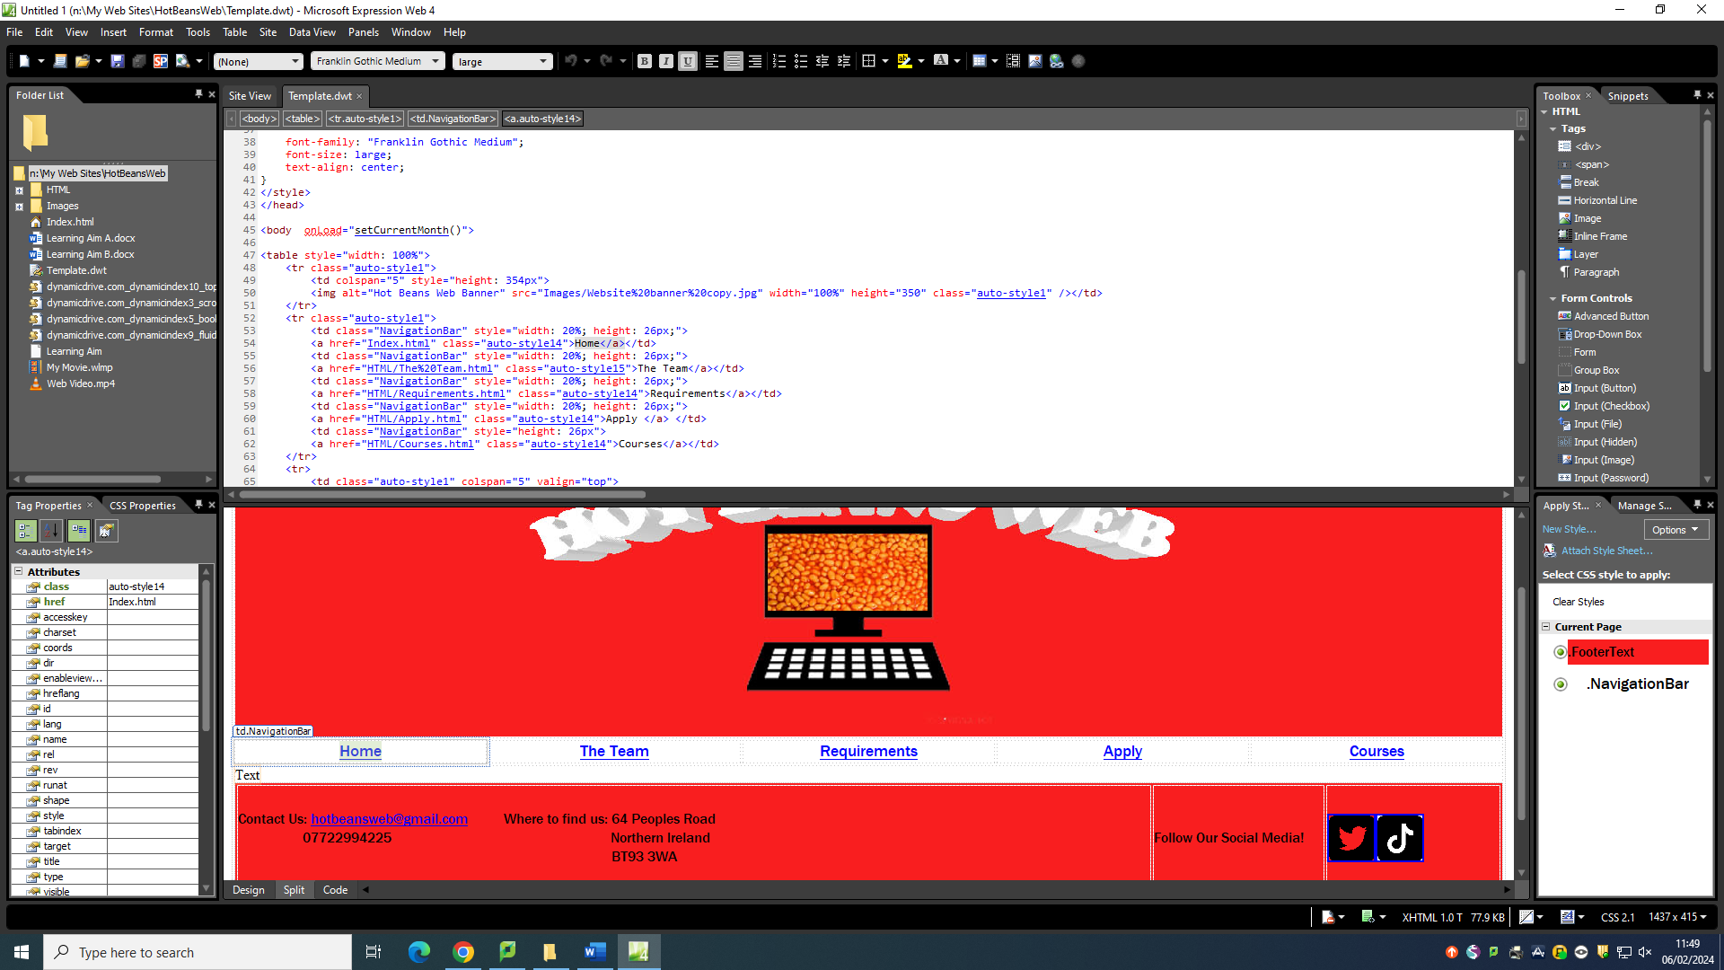On the template of HotBeansWeb I have used CSS and applied it to the text of the navigation bar and named it NavigationBar, this CSS has the font Franklin Gothic Medium size large, and it is centre aligned. I also applied CSS to the text in the footer which has the properties of |font franklin gothic medium, font size medium and has a background colour of F91E1F (red).

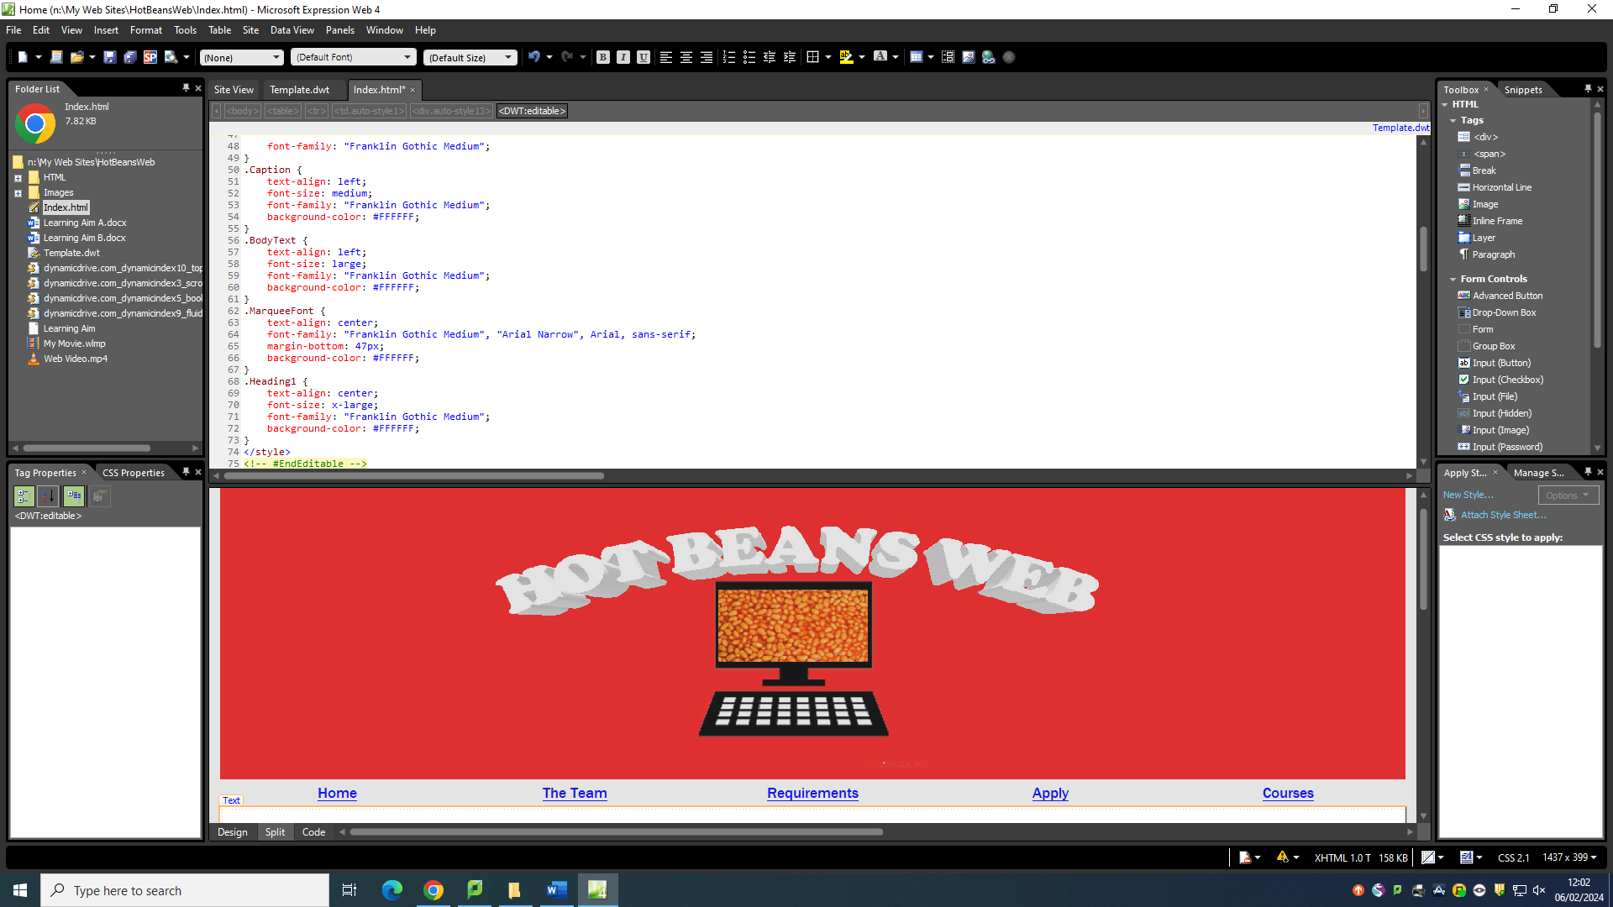

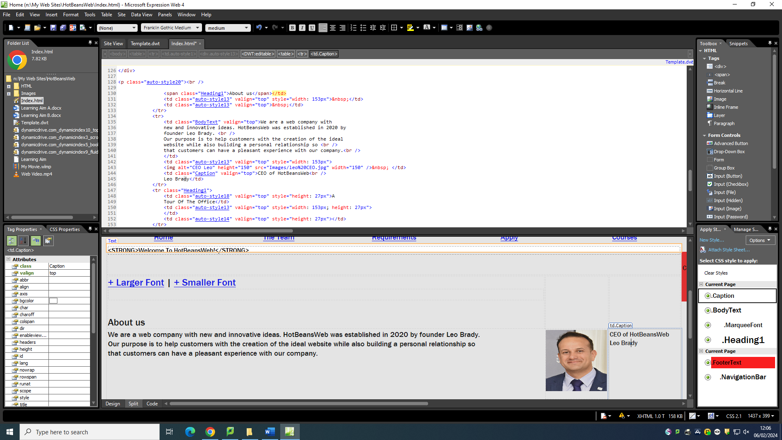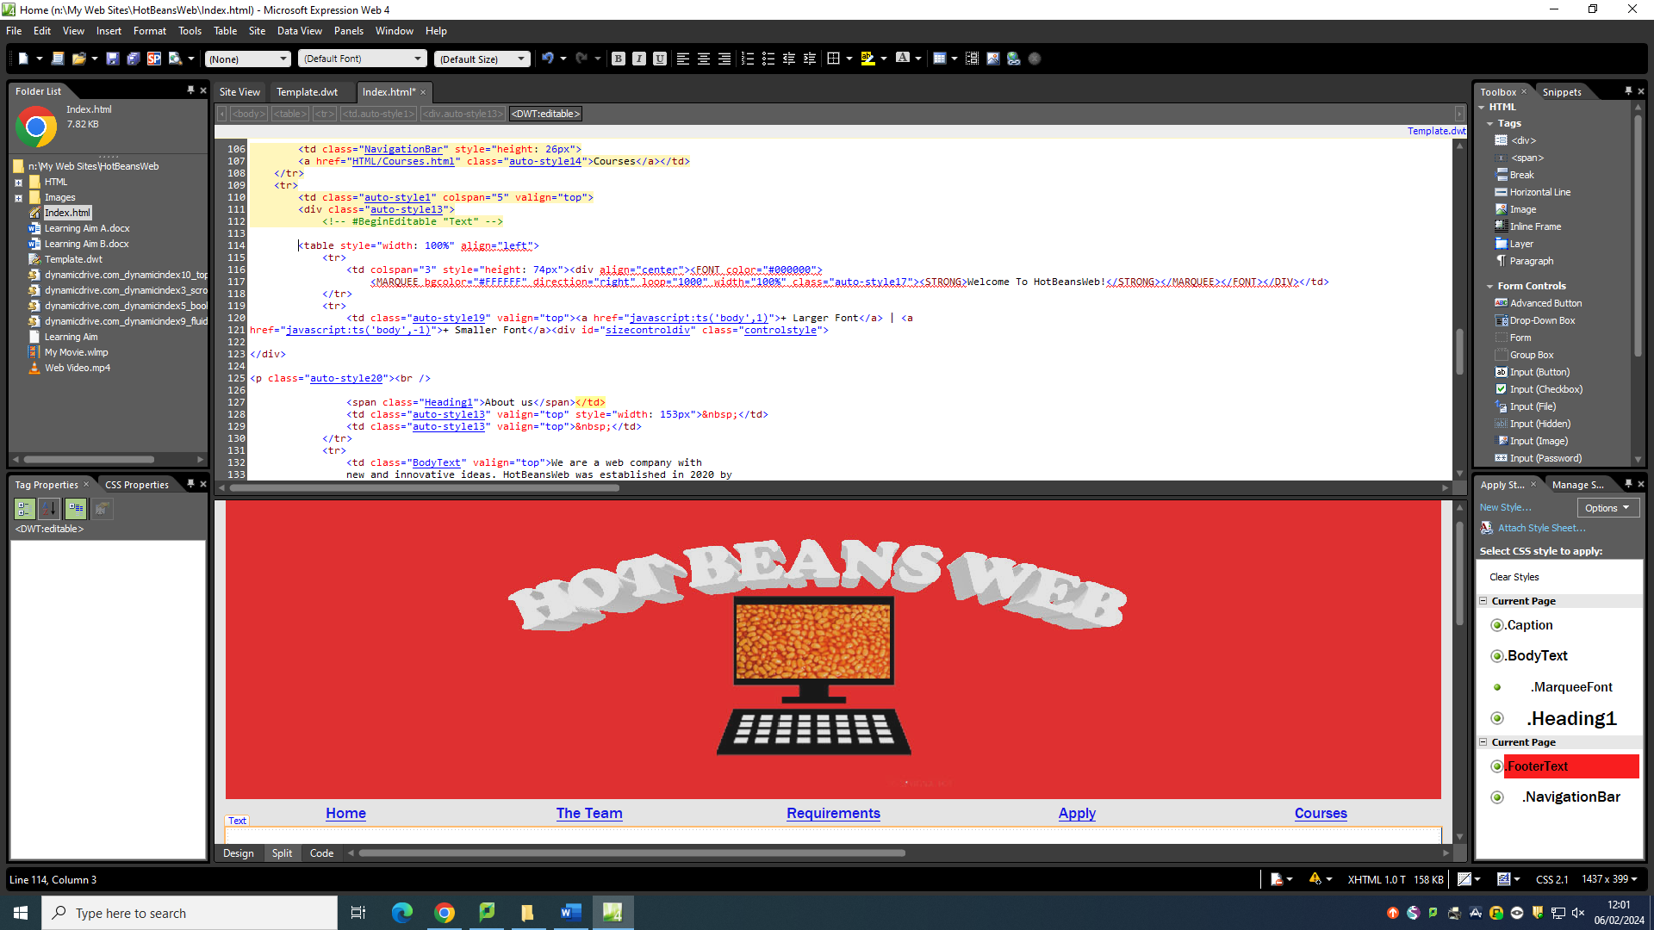

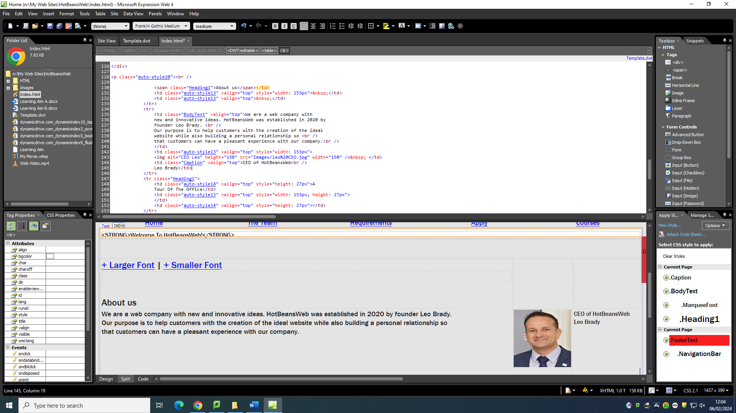

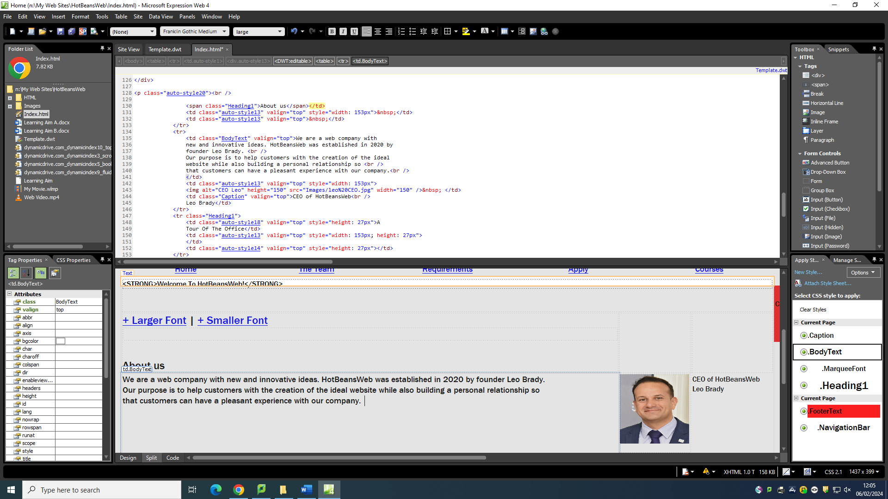

**Legal and Ethical considerations**

Before I designed the website, I had to consider the legal and ethical considerations that are involved. The two laws that I considered during the process of designing was the Copyright, Designs and Patents Act 1988 and the Data Protection Act 1998.

The Copyright, Designs and Patents Act 1988 is a law that protects all original works such as music, art, writing and programming code once it is tangible, which means once it is in a fixed form. These original works are property of the individuals who created them. On the website there are elements on which I have created that fall under the Copyright, Designs and Patents Act 1988. For example, the banner I have created, and the movie are original works as I have created them and own the right to them. The images I have used from google images fall under this act as the people who have created these images are the legal owners of this

The Data Protection Act 1998 was designed to protect sensitive data held in data bases. It is upheld by the information Commissioners office and every business that stores data must register and state the data they plan to hold. There are eight principles of the data protection act 1998 for example the right to compensation for unauthorised discloser of data and the right to get inaccurate data corrected or removed. Data has been collected on my website and therefor is in the data protection act. The data that is being collected is to be input on the application form. The data that has been requested and to be input by users is their name, email address, phone number, title and their CV. This data will all be stored accurately and will not be shared anywhere and is simply for the employer's use.

**Evaluation**

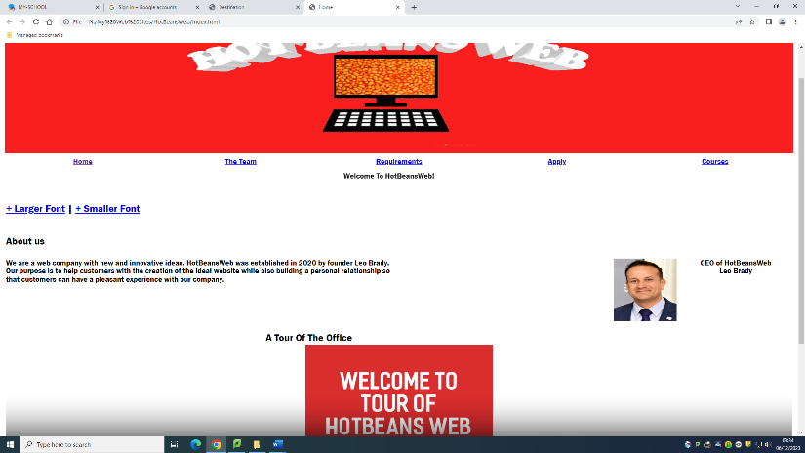At the beginning I was asked to create a website for HotBeansWeb. I was provided with a list of requirements such as, contains a company profile, profiles of exiting trainee web developers, job specification and required qualifications, an online application form and links to web development courses.

**Suitability for intended purpose and audience**

1. Contains a company profile.

I have created a company profile that includes key information of HotBeansWeb. I created the company profile in Microsoft web expression.

1. 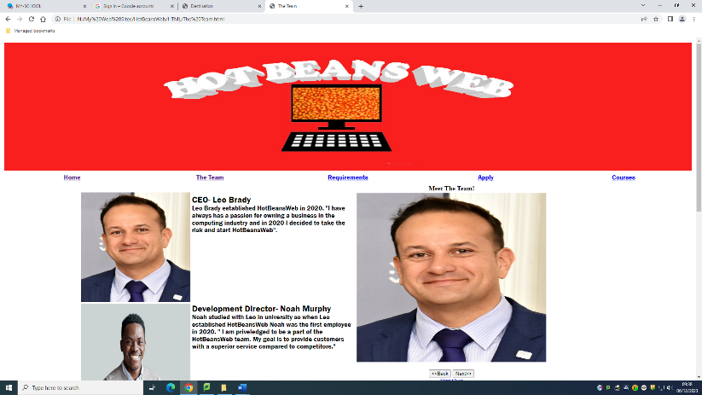Create profiles of existing trainee web developers.

I created profiles of the existing trainee web developers at HotBeansWeb. Their profiles consist of dates they started at HotBeansWeb and what their job is and includes. I created this page using Microsoft Web expression.

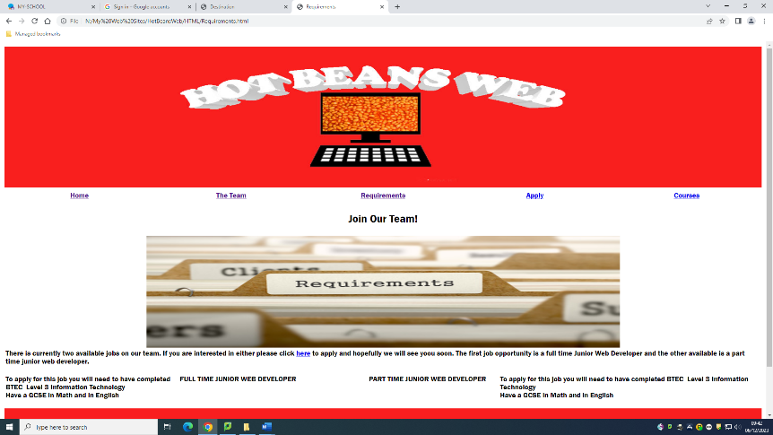

1. Create Job specification and required qualifications.

I included a summary of the jobs that are available at HotBeansWeb and the required qualifications potential applicants should have if they wish to apply for the jobs. I created this page on Microsoft web expression.

1. Create an online application form.

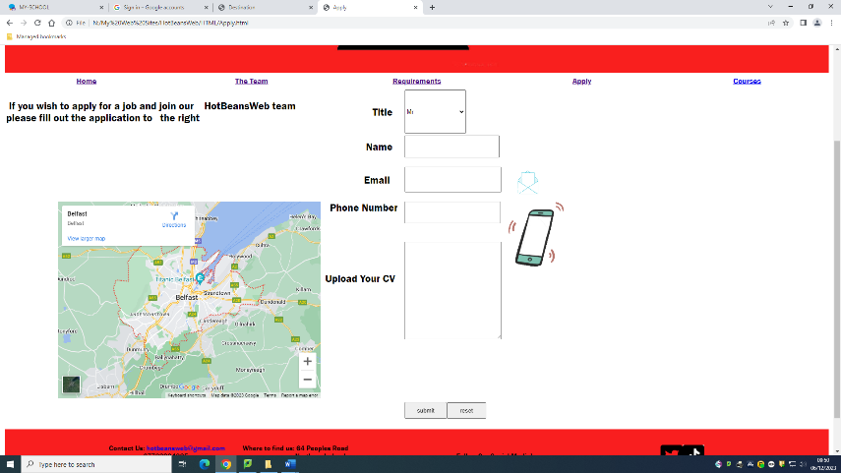I created an on line application form using text boxes, subit button and a reset button. The online application is easy to use. I created the application page on Microsoft web expression.

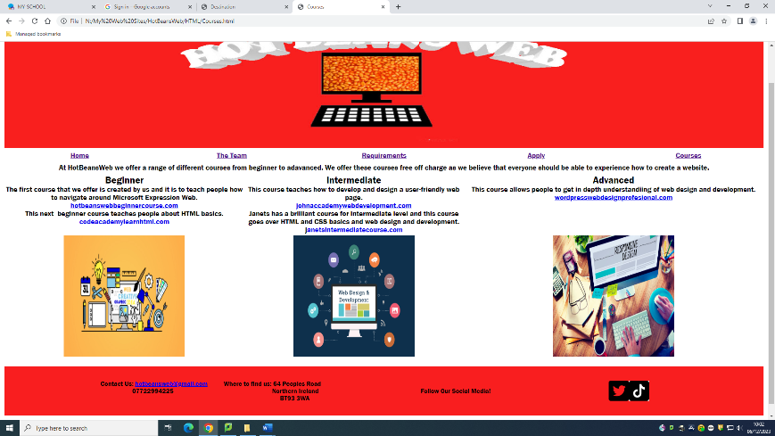

1. Provide links to web development courses.

I have met this requirement and have including thinks to different web development courses. I also separated the courses into distinct experience levels to help users find the most ideal web course for their standard.

**Quality in comparison to other similar websites**

I have completed the HotBeansWeb and I have also compared the website to other similarly themed websites. This is useful as it allows me to create a website that stands out compared to competitors.

I compared the HotBeansWeb website I created to another web development company’s website called arnia software. Before I created the website, I got inspiration from the other website. The inspiration I gathered from this is the idea to use a google map embedded beside the contact/ apply section of website. I liked features on their website such as the white space and the search bar. However, I did not the layout of the website. From comparing the two websites an improvement I would make to HotBeansWeb is including a search bar to improve ease of use. An improvement I would make to arnias website is a more organised and appealing layout.

The other website I compared the HotBeansWeb I created to was Csimedia. Before creating the HotBeansWeb I gathered some ideas from the Csimedia website, I got the idea to add a photo gallery. I added a photo gallery on The team page of hotbeansweb. From evaluating the website to HotBeansWeb there are some similar features such as an organised layout and interactivity. I liked the simplicity of csimedia website although I did not like how some pages were not dynamic. If I had to make improvements to HotBeansWeb website after comparing I would add more of a unique theme.

**Strengths**

The HotBeansWeb banner is a strength of the website. The banner has an eye-catching red colour. This is a strength as it makes the website more aesthetically appeasing which will present to users that the website is professional. Another strength of the website is the scrip I have used, it adds dynamic features to the website which makes the website feel more interactive once again gaining the users attention. I have accessibility to increase or decrease the size of the font which is a strength as it allows the website to be user friendly. Another strength of the website is the video I have included once again it adds an interactive feature to the website. The use of white space throughout the website is a strength as it allows user to rest their eyes making the website more user friendly.

**Weakness**

A weakness of the HotBeansWebsite would be the lack of interactive elements on the Courses page as the only interactive feature is the websites hyperlinked to the course. Another weakness is layout of the application form as it doesn’t utilise the space appropriately and is impractical decreasing the ease of use of the website. A weakness would also be the lack of information which doesn’t provide users with a clear understanding of the website.

**Improvements**

It's important for me to make improvements to the HotBeansWebsite to create a website with positive feedback and meets the clients’ requirements. An improvement I will make is to add more interactive elements to certain pages but not too many that it may be overwhelming to users. Another improvement I will be making is to the layout of the application page to improve the aesthetic of website. I will also be adding more information to the website as an improvement so that users will be able to receive a better understanding of the website.

**Mood Board**



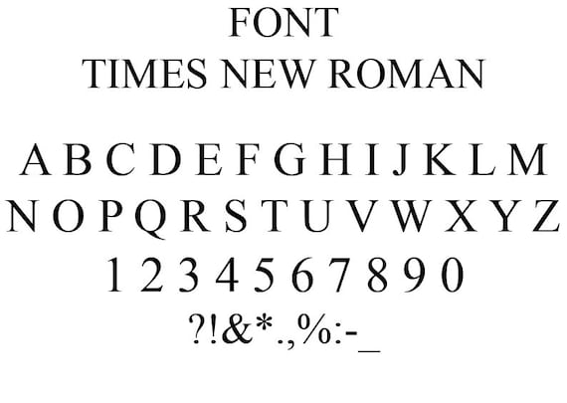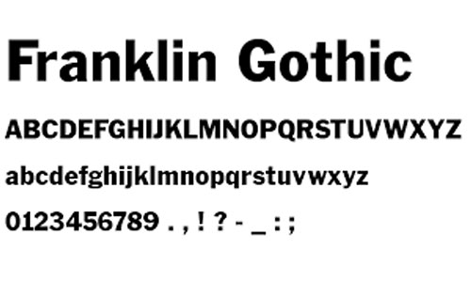

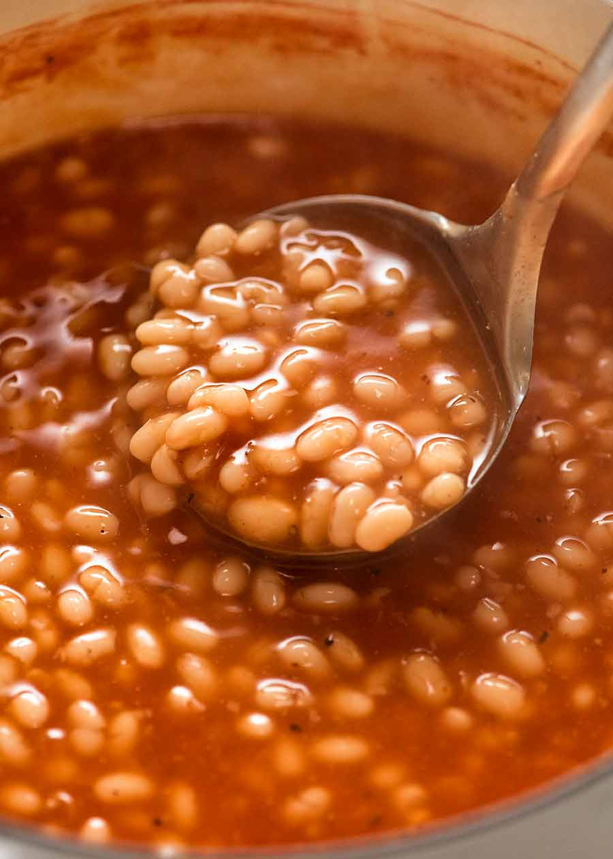



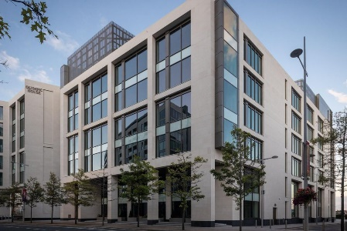



I have presented the mood board to the client HotBeansWeb, they have told me their opinions and they are pleased with the variety of options. They have chosen to go with a red colour scheme and lots of warm colours as they did not like the cool colours shown. They wish to uses franklin gothic medium as a font compared to the times new romans as they want a san serif font so it easier to read for users therefor more user friendly.

**Optimisation**

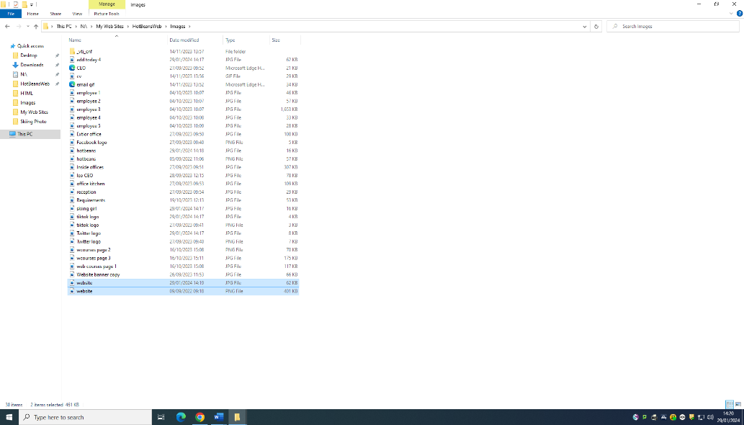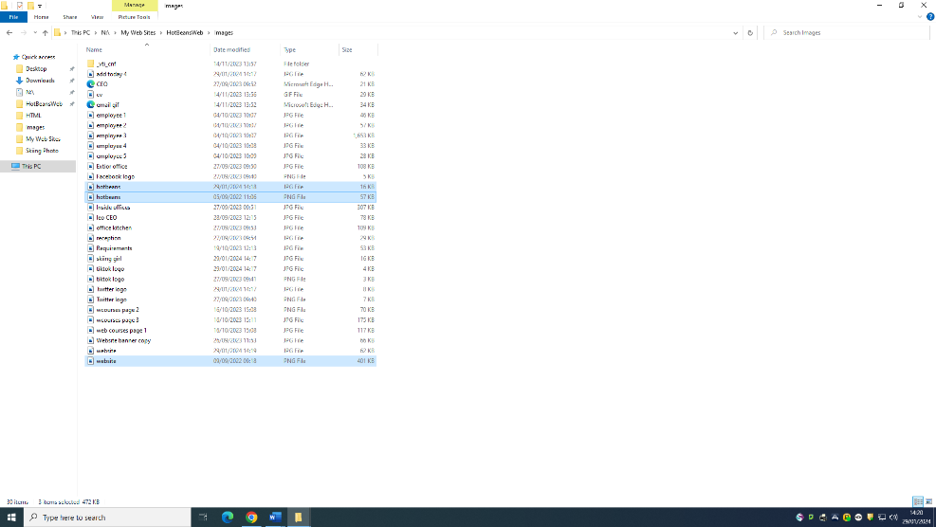

A way to compress the website so it has a quicker loading time is by compressing largeweb files. Compression reduces the bandwidth used by the online tools which enable you this. I have changed the PNG files to JPG files as they take up less storage which will then allow for the website to load quicker.